**Evaluation report**

**Choice Implementation**

I chose to implement choice 4 which was to Compile the engine into a true library. This was simply done by creating a new class library project in the same solution as the rest of the ACW then adding the appropriate references and copying the engine code over from the original project. Then I had to make the classes in the engine code public so when the game code uses the library it can access the classes, I also had to change the namespaces and change the directives to reflect these namespace changes. Some of the engine library code had to be changed to be more generic as before-hand it was relying on have access to certain classes that only exist in the game code.

**AI Algorithms**

I did not manage to implement A.I. for the drone, however, in this section I will outline what my plan was for implementing the A.I. for the drone.

The A.I. component would have access to a node map made up of nine nodes that are positioned in various points on the made and connect to any adjacent node. This can be seen in the diagram below:

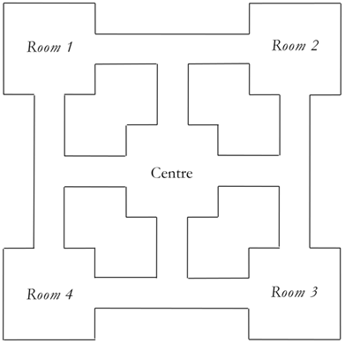

The A.I. would have two motivations, patrol and hunt player. The patrol motivation would be the drones default motivation, while the A.I. is in this state the drone would move around the map following some patterns for patrolling the maze. The primary patrol pattern would simply be the drone moving from room to room ignoring the centre room. The hunt player motivation would be activated when the player enters the line of sight of the drone. The drone would then move to either the players position or the closet node to where the player was seen if the player is no longer in the drone’s line of sight.

**Game Production Evaluation**

Overall, I didn’t face many problems during the course of the project. There were times when I got stuck on certain aspects but it was always a case of me over complicating simple things. One major problem I did have but doesn’t relate to the actual programming was that I lost a small chunk of work due to something going wrong with my GitHub but thankfully I have been keeping another back up of work so I managed to get some of it back.